Content Tool Guide

what is the content tool?
The Content tool is used to create, edit, and organize course materials such as syllabi, lecture notes, video, audio and readings. The Content tool allows users to navigate through course content and activities. You can also:
- Import/Export existing content.
- Change the way your course displays content.
- Create new or link to existing dropbox folders, discussions and quizzes.

how is content organized?
- Modules: Modules are like folders on your computer, and act as an organizational tool that contains information. Modules must be populated with topics (or files) in order to display content.
- Sub-Modules: Sub-Modules are simply modules nested within other modules. Similar to modules, they hold and organize topics.
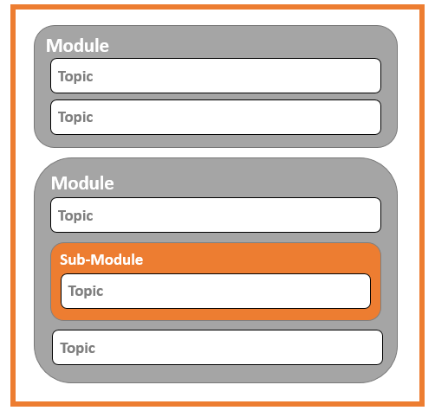
- Topics: Topics are the actual content items. Topics can be created in the Learning Environment using the HTML editor or can be files uploaded into the Learning Environment (.pdf, .doc, .mp4, .ppt, etc.).

content tool structure
Within the Content Tool, you will find four areas:

1. Overview

When users access a course's Content tool for the first time, the first page they land on is the Overview (unless it has been left empty). Use the Overview page to orient users to the course, content materials, and course expectations. You can insert course overview information using the HTML Editor beneath the Overview title, and you can add a file attachment by dragging a file from your computer onto the upload target, or by clicking Add an Attachment from the Overview context menu.

2. Bookmarks
The Bookmarks area is a user-specific place that holds links to bookmarked content topics. Click the Add Bookmark icon while viewing a topic to add it to your bookmarks list. The number beside the Bookmarks link indicates how many bookmarks you have.

3. Course Schedule
The Course Schedule area shares dates for the course, including due dates. When items are overdue, the dates will appear as red. The links that appear with the dates will allow learners to click directly on the item that needs to be completed.

4. Table of Contents
The Table of Contents panel lists all modules and topics available in your course. You can add new topics to existing modules by dragging and dropping files from your computer onto upload targets on the Table of Contents page, and you can also rearrange course materials by dragging and dropping topics between modules. The number beside each module name in the Table of Contents panel listing indicates the number of topics you have set completion tracking for.

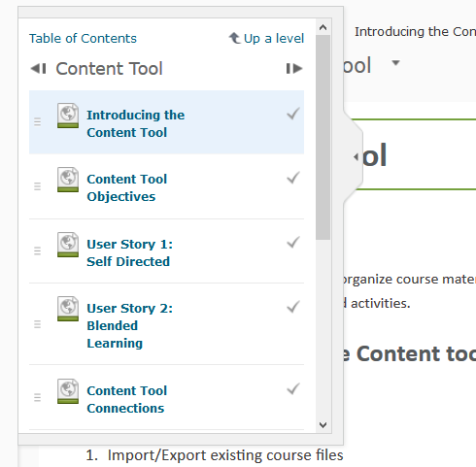
content features
Content Map: When viewing a content topic, hover over the expandable left panel to quick navigate to any topic within the course.
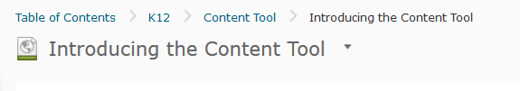
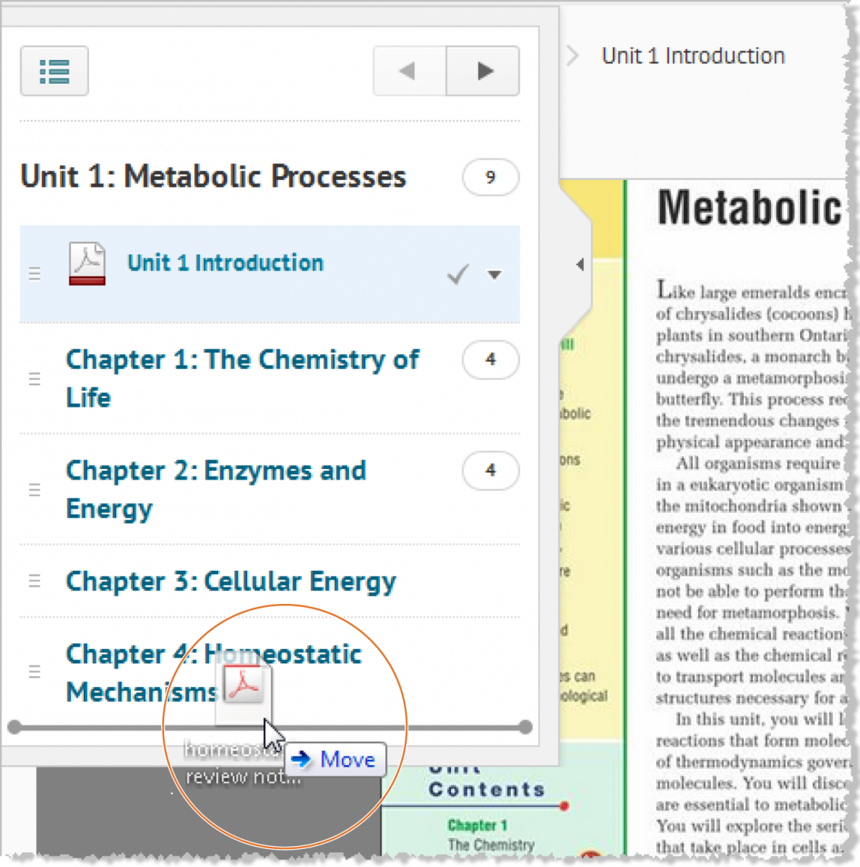
Breadcrumb Trail: The breadcrumb trail allows you to quick navigate without having to page backwards.
Drag and Drop: The drag and drop feature allows you to move modules, sub-modules and topics around easily. A horizontal line will indicate an item being dropped. Highlighting orange will indicate an item being placed inside another item (e.g., a sub-module being placed into a different module).

creating content from scratch
- Create a module to hold your topics by clicking on the Add a Module bar and naming your module.
- Click on and select Create a File.
- Enter content into the HTML Editor (see the HTML Editor Guide for further information).
- Click on Publish.

adding files
Pre-existing files can be placed by dragging them from their home on your computer to the drag and drop box at the top of each module. Alternatively, click and select Upload Files to add the file to content.

adding existing activities
There are multiple tools that can be incorporated into the content stream. These include Discussions, Quizzes, Checklist, Dropbox, Self- Assessment and Survey tools. You can insert these tools in the content stream using the Add Existing Activities button. You can use an existing quiz/ discussion/ etc. or create a new one inline. Once added, that tool will show up as part of the content stream and will display in-line with the tool.

USING Document templates
The document templates area of the Content tool allows you to customize and stylize your content documents. Start by creating a series of HTML document templates and save them in the Manage Files area of the Content tool. As you create your content topics you can easily access the Select a Document Template action button and access your HTML document templates, allowing you to style your content topics.
Note: Admins will need to enable the HTML Templates and ensure that a template directory is set via the Config Variable Browser.

user story
Professor Butler teaches a human nutrition course. She has found a great interactive web site where students can enter what they eat each day and then print out an analysis of their diet for calories, fat, sugar, etc. She decides to provide a link to the interactive diet website in the content area for the appropriate module on nutritional analysis of food. She asks the students to enter their meals on the site daily for a week. The students appreciate that the content for their course is varied and incorporates different multi-media elements all in one easy-to-navigate location!

want more informatioN?
Visit the Brightspace Community (https://community.brightspace.com) or D2L Resource Centre (https://documentation.desire2learn.com) for videos, documents and other resources.

About D2L

A global leader in EdTech, D2L is the creator of Brightspace, the world’s first integrated learning platform. The company partners with thought-leading organizations to improve learning through data-driven technology that helps deliver a personalized experience to every learner, regardless of geography or ability. D2L’s open and extensible platform is used by more than 1,100 clients and 13 million individual learners in higher education, K–12, healthcare, government, and the enterprise sector—including Fortune 1000 companies.
The company has operations in the United States, Canada, Europe, Australia, Brazil, and Singapore.
© 2014 D2L Corporation.
The D2L family of companies includes D2L Corporation, D2L Ltd, D2L Australia Pty Ltd, D2L Europe Ltd, D2L Asia Pte Ltd, and D2L Brasil Soluções de Tecnologia para Educação Ltda.
Brightspace, D2L, and other marks (“D2L marks”) are trademarks of D2L Corporation, registered in the U.S. and other countries. Please visit D2L.com/trademarks for a list of other D2L marks.

